4.2 Integration Testing

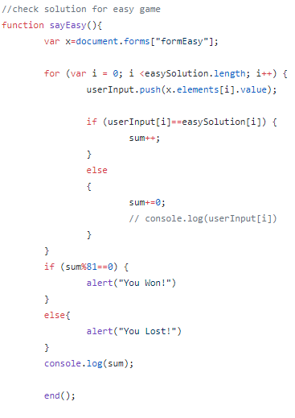

Figure 7- This function checks the answer that the user inputted by pushing the values to an array, and comparing the array with a solution array. If all the values match, the answer will be “you lost” and if any of the values don’t match, the output will be “you lost”. This function is the submit function of the game, after we check the answer, we will need to calculate the time of the game. This is done by calling another function, the “end()” function shown in figure 8

*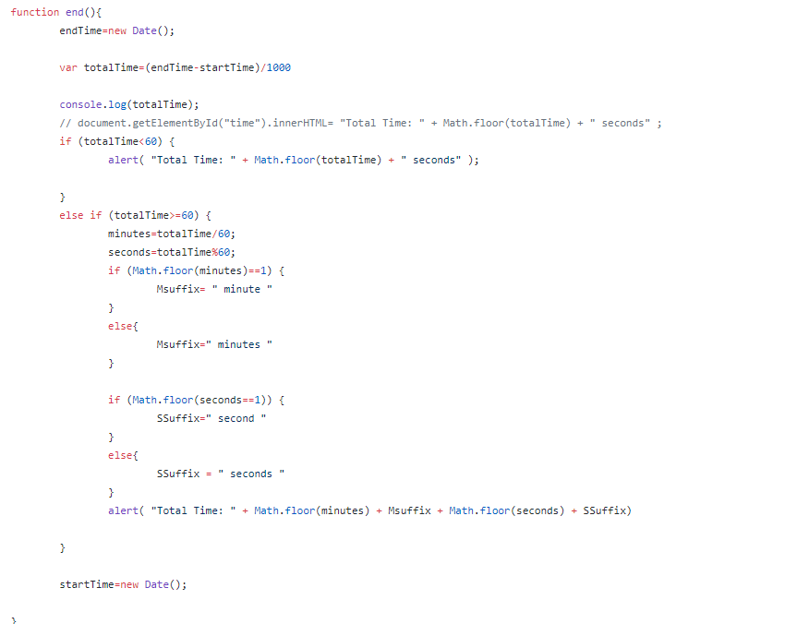*

Figure 8- This function calculates the time it takes for the user to finish the game. The output will be the time that the page has been loaded for until the user clicked submit. It will be in minutes if the time is longer than 60 seconds. The function will work whether the user has won or lost their game.

This shows the integration of the sayEasy() function with the end() function as it tracks the time when the user solves the puzzle. This is implemented with an alert function in the app. These functions work together. This was tested and all possible outputs work successfully.

Other Functions: The other functions do not have integrations as they are not dependant on each other for the outputs. Other functions like userValidation(), showMusic(), they have all the required variables to be implemented. It does not need any calls from other functions or to other functions to work.